**CSC-632 Assignment 4**

Author: Yunting Chiu

Email: [yc6705a@american.edu](mailto:yc6705a@american.edu)

**QUESTIONS:**

Z-table: <https://www.ztable.net/>

1. (1 point) Given that z is a standard normal random variable, compute the following probabilities.

Z- score: if the z-score is positive, indicating that the score is higher than the mean value. If the z-score is negative, this indicates that the score is lower than the mean value.



a) P(z ≤ −1.0)

The z score of -1 is .15866.

P(z ≤ −1.0) = .15866.

b) P(z ≥ −1)

P(z ≥ −1) = 1 - P(z ≤ -1). Then we should focus on the z-table. according to the z-table, the z score of -1 is .15866.

P(z ≥ −1.0) = 1-P(z < -1.0) = 1 - .15866 = .84134

2. (1 point) Given that z is a standard normal random variable, find z for each situation.

a) The area to the left of z is .2119.

The probability of .2119 corresponds to a z score of -0.8.

b) The area between −z and z is .9030.

The probability is .9515, so the z-score is 1.66, according to the z-table.

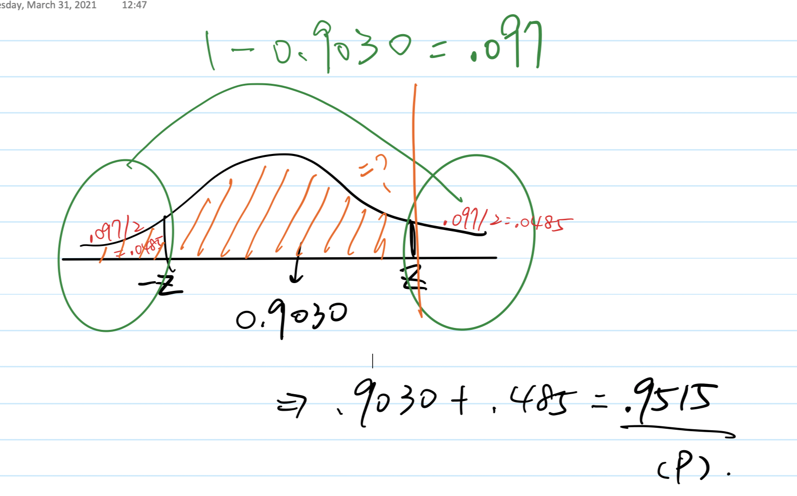

3. (2 point) The U.S. Energy Information Administration (US EIA) reported that the average price for a gallon of regular gasoline is $2.94. The US EIA updates its estimates of average gas prices on a weekly basis. Assume the **standard deviation is $.25** for the price of a gallon of regular gasoline and **recommend the appropriate sample size** for the US EIA to use if they wish to report each of the following margins of error at **95% confidence**.

Because this question is about how we estimate sample size, the following equation is :



a) The desired margin of error is $.10.

A margin of error tells us how many percentage points your results will differ from the real population value.

E = .10

Critical value of 95% confidence interval = Z $\alpha$/2 = NORM.S.INV(0.975) = 1.96

n = (1.96)^2 * (.25)^2 / (.1)^2 = 24.01

**Ans: the appropriate sample size is 24 for the US EIA if the desired margin of error is $.10.**

b) The desired margin of error is $.07.

E = .07

Critical value of 95% confidence interval = Z $\alpha$/2 = NORM.S.INV(0.975) = 1.96

n = (1.96)^2 * (.25)^2 / (.07)^2 = 49

**Ans: the appropriate sample size is 49 for the US EIA if the desired margin of error is $.07.**

c) The desired margin of error is $.05.

E = .05

Critical value of 95% confidence interval = Z $\alpha$/2 = NORM.S.INV(0.975) = 1.96

n = (1.96)^2 * (.25)^2 / (.05)^2 = 96.04

**Ans: the appropriate sample size is 96 for the US EIA if the desired margin of error is $.05.**

4. (1 point) A simple random sample of 50 items from a population with sigma = 6 resulted in a sample mean of 32.

a) Provide a 90% confidence interval for the population mean.

Ans: [30.60417, 33.39583]

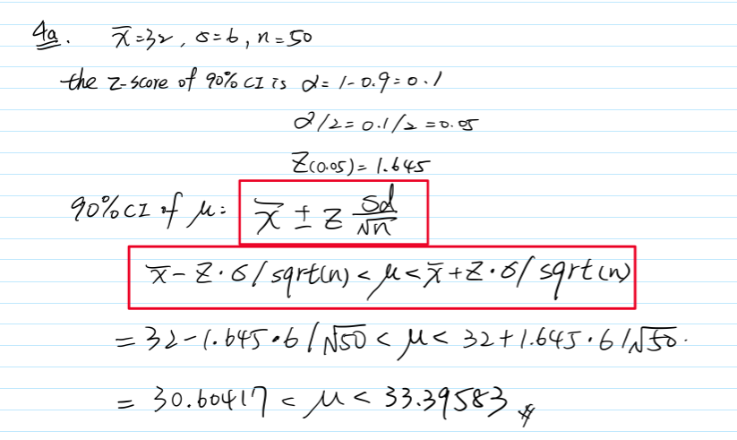

b) Provide a 95% confidence interval for the population mean.

Ans: [30.33688, 33.66312]

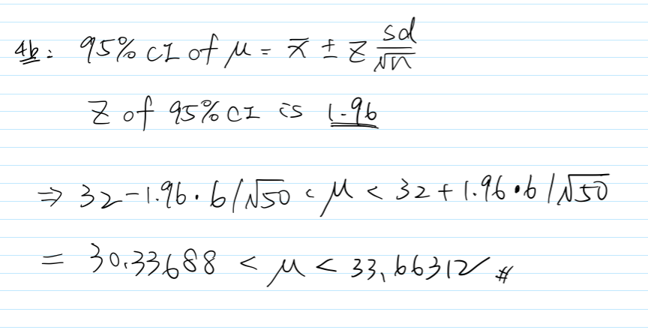

c) Provide a 99% confidence interval for the population mean.

Ans: [29.81419, 34.18581]

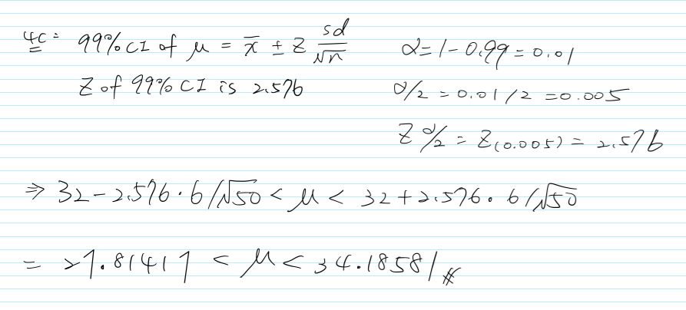

5. (2point) A simple random sample of 400 individuals provides 100 Yes responses.

That is, x = 100 (providing YES responses), n = 400.

a) What is the point estimate of the proportion of the population that would provide Yes responses?

point estimate of the proportion = phat = 100/400 = .25 = 25%

b) What is your estimate of the standard error of the proportion, sigma_p?

Standard error = Sqrt( phat ( 1 - phat) / n) = sqrt(.25*(1-.25) / 400) = .02165064

c) Compute the 95% confidence interval for the population proportion

The formula is :

phat - Z * sqrt(phat * (1- phat) / n < phat < phat + Z * sqrt(phat * (1- phat) / n

= .25 - 1.96 * sqrt(.25 * (1- .25) / 400) < phat < .25 + 1.96 * sqrt(.25 * (1- .25) / 400)

= [.2075648, .2924352]

6. (1 point) The random variable x is known to be uniformly distributed between 10 and 20.

a) Show the graph of the probability density function.

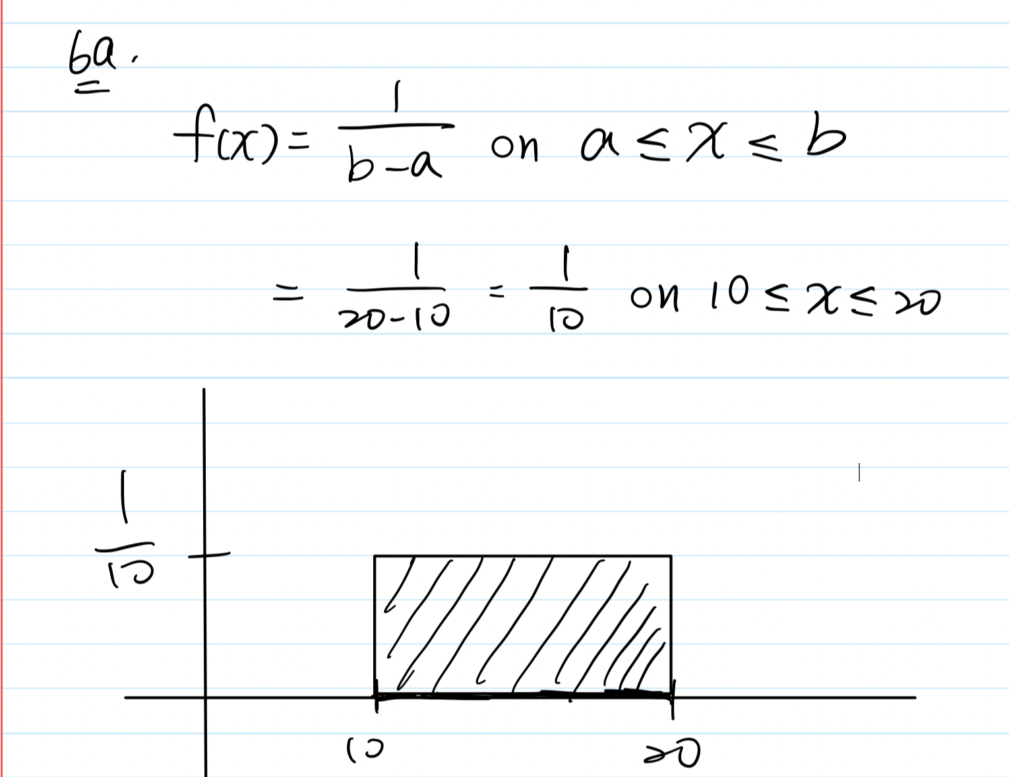

b) Compute P(x < 15).

f(x) * size = 1/10 * (15-10) = .5

c) Compute P(12 ≤ x ≤ 18).

= 1/10 * (18-12) = .6

d) Compute E(x). (expected value of x)

mu of x = 10+20 / 2 = 30 / 2 = 15

e) Compute Var(x).

Uniform variance: (b-a)^2/12 = (20-10)^2 / 12 = 100 / 12 = 8.333333

Reference: <https://youtu.be/ieFxnBU8stM>

7. (2 point) Consider the following hypothesis test:

H0: Mu >= 20

Ha: Mu < 20

a) A sample of 50 provided a sample mean of 19.4. The population standard deviation is 2.

b) Compute the value of the test statistic.

z score is -2.12132

c) What is the p-value?

* According to the hypothesis test, we will focus on a one-sided test. The p-value is .016961
* p-value calculator: <https://www.socscistatistics.com/pvalues/normaldistribution.aspx>

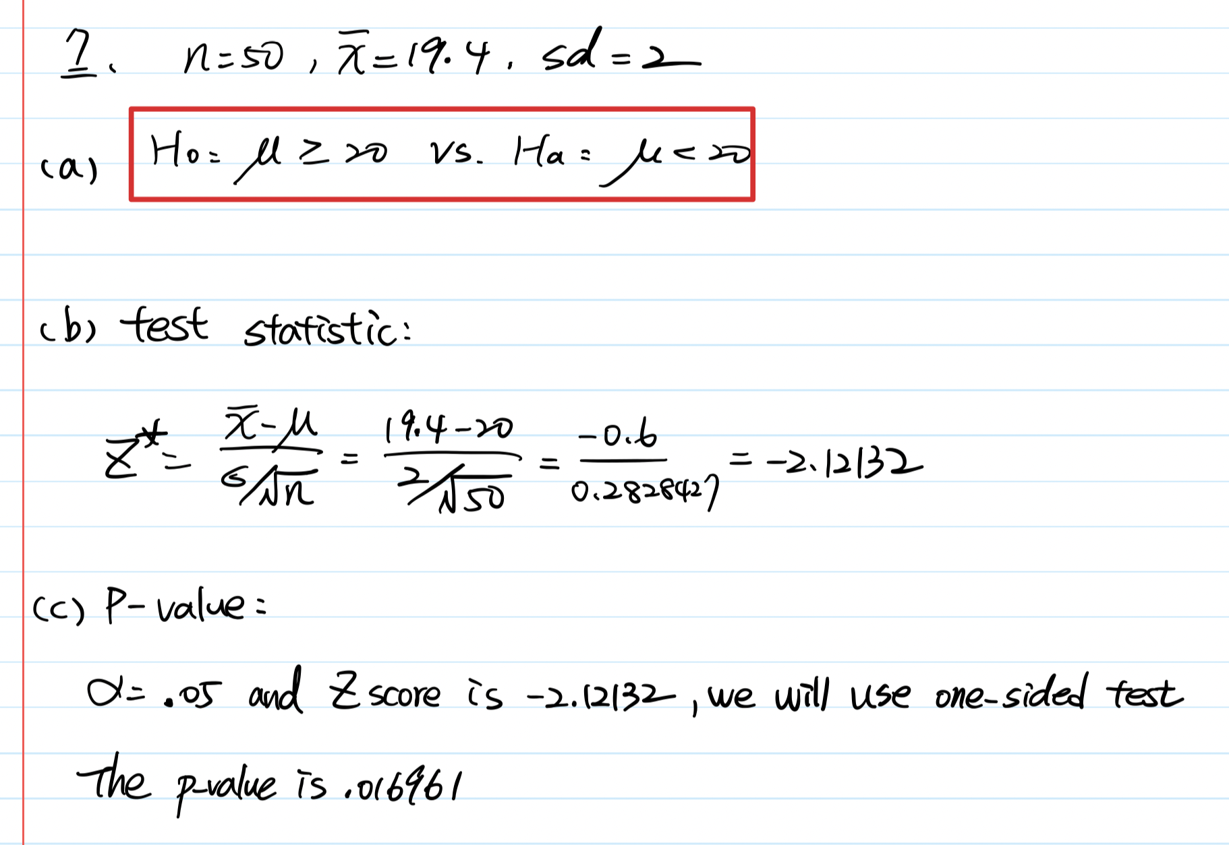

d) Using alpha = .05, what is your conclusion?

P(Z < -1.645) = .05

With the small p-value .016961, we have evidence to reject the null hypothesis in favor of the alternative hypothesis, meaning that the population mean is not greater and equal than 20 or there is sufficient evidence to conclude that the population mean is less than 20 with 95 % confidence interval.

e) What is the rejection rule using the critical value? What is your conclusion?

Reject H0 if Z < -1.645 and do not reject H0 is Z > -1.645

We can see we still can reject the null hypothesis with statistical evidence below. So we still have evidence to conclude that the population mean is less than 20 with 95 % confidence interval.

